**# What is a Git Repository:**

* A Git repository tracks and saves the history of all changes made to the files in a Git project. It saves this data in a directory called .git, also known as the repository folder, and this .git directory is by default hidden.

* Git uses a version control system to track all changes made to the project and save them in the repository.

_ _ _ _ _ _ _ _ _ _ _ _ _

**# Git - File Status Lifecycle:**

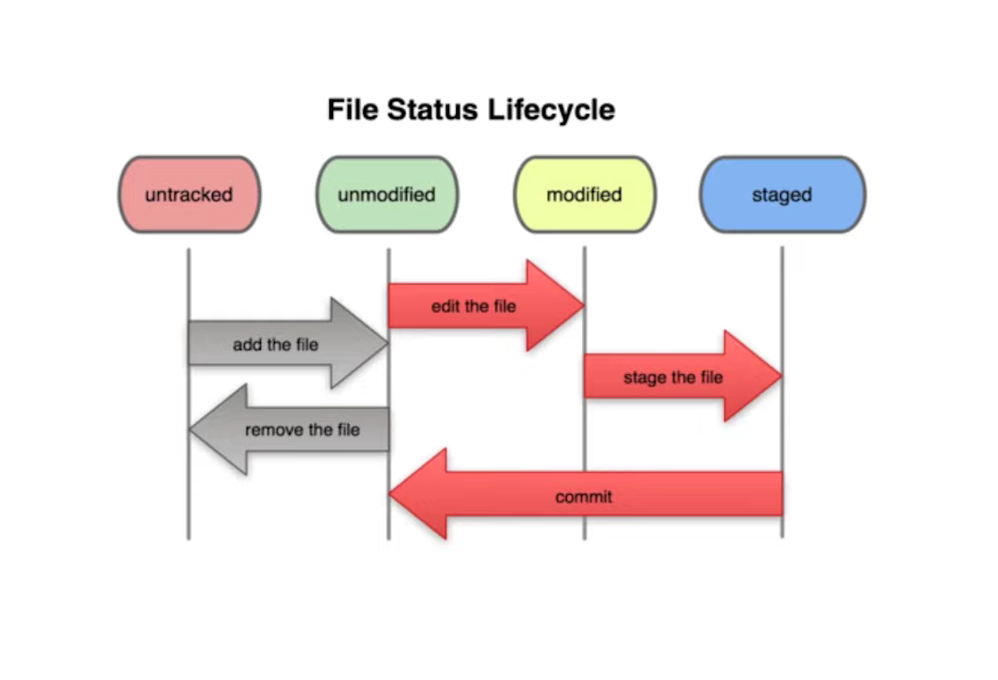

1st Untracked

2nd Being Tracked / Unmodified / Staged

3rd Modified

4th Staged -----> Commit -----> 2nd Unmodified.

_ _ _ _ _ _ _ _ _ _ _ _ _ _ _ _ _ _ _ _ _ _ _ _ _ _

**# States of a File in Git Working Directory:**

* Each file in the working directory can be in one of two states:

(i) Untracked

---> Untracked files are any files in the working directory that were not in the last snapshot and are not in the staging area

(ii) Tracked

---> Tracked files are files that were in the last snapshot.

---> These are files that Git knows about.

---> Each track file can be in one of three sub-states, modified, staged, or committed.

_ _ _ _ _ _ _ _ _ _ _ _ _

**# Three Sub-States of Tracked Files are:**

a) Modified:

---> A file in the modified state means that changes have been made to it that haven’t committed yet.

b) Staging:

---> A file in the staging state means either it is not present in the last commit (e.g. newly created files) or it is “modified” file that user tells git to include in the next commit.

c) Committed:

---> A file in the committed state means that the changes made to it are safely stored in a snapshot in the Git directory.

_ _ _ _ _ _ _ _ _ _ _ _ _ _ _ _ _ _ _ _ _ _ _ _ _ _

**# References Cited:**

* 6th Video of CodeWithHarry (Complete Git Tutorials For Beginners In Hindi) Playlist : (Git: File Status Lifecycle | Git Tutorials #6):

<https://www.youtube.com/watch?v=PArS4YeAq8w&list=PLu0W_9lII9agwhy658ZPA0MTStKUJTWPi&index=6>

* PheonixNAP (What is a Git Repository?):

<https://phoenixnap.com/kb/what-is-a-git-repository#:~:text=A%20Git%20repository%20tracks%20and,save%20them%20in%20the%20repository>.

* GeeksFoGeeks (States of a File in Git Working Directory):

<https://www.geeksforgeeks.org/states-of-a-file-in-git-working-directory/>

_ _ _ _ _ _ _ _ _ _ _ _ _ _ _ _ _ _ _ _ _ _ _ _ _ _ _